Em ------ D6/9 ------ Em9 ------ Dmaj9 ------
|||||| |||||| |||||| xx||||
|12||| 1||2|| |1|||3 |||23|
|||||| |||||| |||||| ||||||

INTRO: ||: Em | D6/9 | Em | D6/9 :||

Em D6/9
On the first part of the journey
Em D6/9
I was lookin’ at all the life
Em D6/9
There were plants and birds and rocks and things
Em D6/9
There were sand and hills and rain

Em D6/9
The first thing I met was a fly with a buzz
Em D6/9
And the sky with no clouds
Em D6/9
The heat was hot and the ground was dry
Em D6/9
But the air was full of sound

CHORUS:
Em9 Dmaj9
I've been through the desert on a horse with no name
Em9 Dmaj9
It felt good to be out of the rain
Em9 Dmaj9
In the desert you can remember your name
Em9 Dmaj9
'Cause there ain't no one for to give you no pain
Em9 Dmaj9 Em9 Dmaj9
La la la la lalala la la la la la
Em9 Dmaj9 Em9 Dmaj9
La la la la lalala la la la la la

Em D6/9
After two days in the desert sun
Em D6/9
My skin began to turn red
Em D6/9
After three days in the desert fun
Em D6/9
I was looking at a river bed
Em D6/9
And the story it told of a river that flowed
Em D6/9
Made me sad to think it was dead

[REPEAT CHORUS]

Em D6/9
After nine days I let the horse run free
Em D6/9
'Cause the desert had turned to sea
Em D6/9
There were plants and birds and rocks and things
Em D6/9
There were sand and hills and rain
Em D6/9
The ocean is a desert with it's life underground
Em D6/9
And the perfect disguise above
Em D6/9
Under the cities lies a heart made of ground
Em D6/9
But the humans will give no love

[REPEAT CHORUS]

ENDING:

||: Em | D6/9 | Em | D6/9 :|| and FADE

Strum pattern:

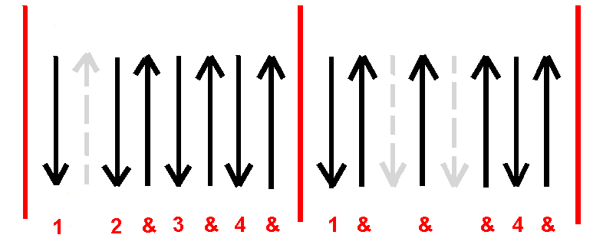
Em D6/9

